**Lecture No. 2**

URL of my repository

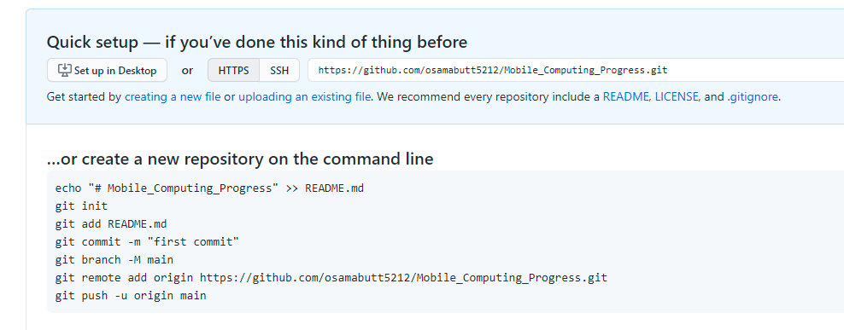

Cloning a Repository

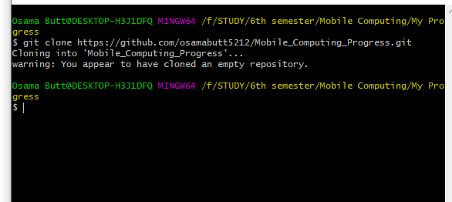

Signing In

